Faith, Luis, Sam

To The Moon

Fall 2021

Butter Melt

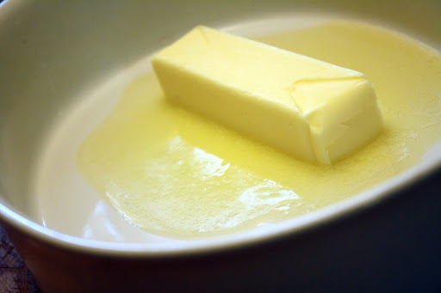

# About the game

In this game, the player must either stop a stick of butter from melting or cause it to melt. The player will be hit with various obstacles that prevent the goal from being reached. To combat these obstacles the player must use items. These items can be bought through an in-game currency that the player earns the longer they keep the butter at the desired state. This is heavily inspired by both Plants Vs. Zombies and Mario Party.

## Why Mobile

This game is a great design for mobile because it is a very simple, laid-back game. The player can easily start playing at any time and leave whenever they want. The story is also quite loose that doesn’t require a very large time investment to follow. This makes it perfect as a mobile game.

Scenario

There is to be a birthday on the moon that they need to make a cake for. The butter is a necessary ingredient but was forgot on Earth. So thus, the Butter Program is born. The only issues are that the butter is in unstable and needs to be kept at the perfect temperature. The player plays as an esteemed baker that must keep the butter safe.

## Genre

Butter melt is in the casual genre. Similar to games such as Plants vs Zombies, the game has a small challenge and is easy to learn. In general, the idea of the game is to be something small you can play while riding the train or waiting in line.

## Target Audience

Everyone who has delt with the frustration of keeping something out of the fridge too long

ANYONE with free time

Space lovers

Bakers

References

Plants v Zombies inspired our progression system and difficulty curve. One example of our progression inspired by Plants vs. Zombies. Their shop involves gaining suns and spending them on defenses against the incoming zombies. We are implementing a similar system by having the player collect Doge coin to get items to help the player get to the Moon and save the day!

***LUIS WRITE HERE*** Mario Party

## Key features & Mechanics

The player must use items to either stop a stick of butter from melting or cause it to melt. The player will gain coins the longer the butter is kept alive. These coins will allow the player to purchase items to make keeping the butter alive easier. These items can include a fan, wind, ice storm, snow, lower temperature, heat wave, hot breeze, heater, oven, or fire.

# Game Mechanics and Dynamic

how does this game work? How is it played? And what kind of game dynamics do you expect?

## Concept Art

Menu Screen Background

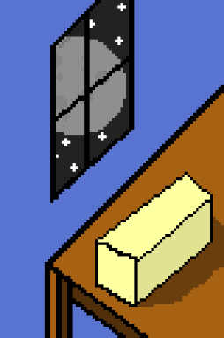

Options

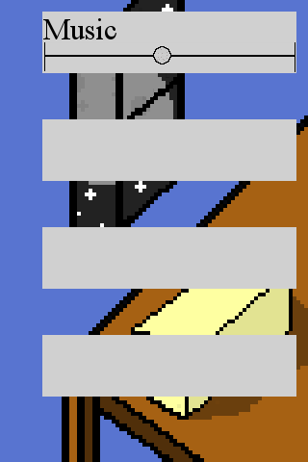

Start

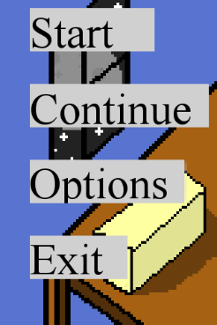

Credits



How to play

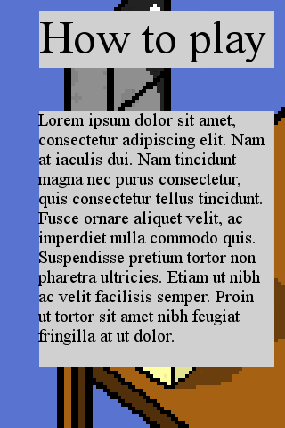

Lab

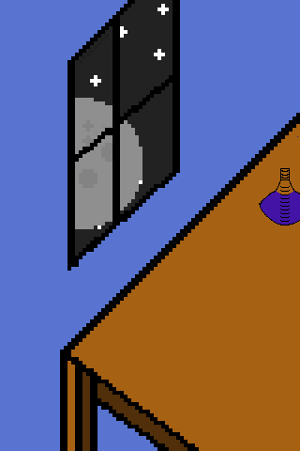

Rocket

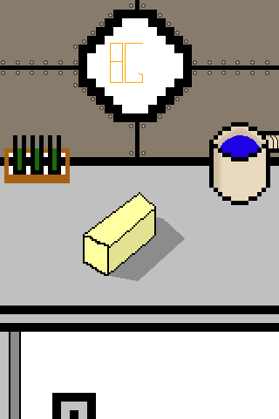

Going to space



Orbits to moon

Sun flyby

Landing on Moon

Party Screen

## Game Mechanics

## Scoring System and Achievements

## Interface

## Game Flow

## Screen Flow

# Tech

What do you need to make this game?

Solar 2D game engine

Gimp

Lua

## Tech Aspects

## Resources

## Game Assets

### Sprites

ifgsjk

### Audio

Fjsekl;m

## Camera Information

Isometric camera, 3D thanks to the drawing, but not in programming.

## Schedule